CSP/Eval Account Creation - Functional Spec

Contents
Overview 1
Scenarios 2
CSP 3
Self Service Registration 3
Device Registration and Add VM-Series Auth-Code 4
Company Account 4
Salesforce VM Eval Request Services 5
Eval Account Conversion Flowchart 6
Eval Tracker 7
Transfer to Customer Site 7
Admin Site 7
SE Device Creation 7
Entitlement Search 8
Salesforce 8
VM Eval Requests 8

Overview
The goal of this project is to automate the account creation for Eval Requests in the Customer Support Portal. Currently Nancy’s CSR team must manually create all new eval support accounts which is time consuming for them and makes the sales process less seamless.
By identifying all Eval Requests as they are made and then logging the request and creating a support account immediately we’ll allow users to self-service register with an EVAL ID and/or SE’s to set up an account white-glove style for the end users without CRS involvement.
A parallel project is underway in the Salesforce team to completely replace the Eval Tracker with a Salesforce implementation. This will make part of our changes redundant, but other parts will be necessary to make anyway and aren’t wasted effort. Management is aware of this but feels this piece is important enough to move forward anyway.

Scenarios
Scenario 1 – An eval is generated through Eval Tracker for a new customer and the SE wants to provide White Glove service
An SE decides to provide an eval to a customer for a physical devices so they head to EvalTracker. After whacking a device they fill out the form to transfer the eval to a “Customer Site”. EvalTracker requests and enforces a valid EvalID and alerts them of what SF Account that ID is tied to. Upon reviewing and submitting the results Eval Tracker automatically creates the new support account. The SE then signs into the CSP and uses the “Change Account” window to select the new customer. They are now free to register the eval device and activate trials. They even create a membership for a user and email the credentials to their customer.
Scenario 2 – A VM Eval is generated through Salesforce and the customer self-service registers into the account to set it up themselves
An SE decides to provide an eval to a customer for a VM device so they head to Salesforce and request/generate the eval and auth code from there. Salesforce calls a new web service to alert CSP of the request and CSP generates a new support account for the eval and logs the related auth codes. The SE then goes back to update the Salesforce request with 2 new auth codes that are part of the eval, but generated later. Salesforce calls the web service again with the new auth codes and they are logged by CSP. Finally the end user receives an email from the SE with the instructions for self service registration, their Eval ID and their auth codes. They register and the CSP compares their Eval ID and auth codes against those provided to the web service. They match so the user is granted access as a super user (they were the first user of the account).
Scenario 3 – a VM/Panorama eval is improperly generated through the AdminSite SE Devices page
Although they shouldn’t an SE generates an eval through the admin site using the SE devices page. They are prompted to register this device for an eval which allows them to enter an EvalID for the device. The admin site immediately creates the customer’s eval support account (using the same mechanism that EvalTracker uses) and logs the request. The SE can immediately see the eval customer account in CSP and can either set up the account, white glove style, for the customer, or allow them to self service register. If the customer self-service registers, then their auth code/serial number and Eval ID will first be compared to the sales order table (it won’t be there), then to the eval tracker table (it won’t be there either) and finally to the SE devices eval table (it will be there) and they are granted access.
Scenario 4 – Eval customer converts to paid customer using “Register Device”
A customer with an eval account tries to register a non-eval serial number or VM using the Register Device or Add VM-Series Auth-Code button. The CSP site stops them with a warning:
“To register a new purchased asset, the Eval account must be converted to an active CSP account. Please go to the Company Account page to activate your account.”
On the Company Account page the customer will have a textbox for Serial Number or Auth Code and a button titled “Activate your account”. Upon clicking it, if the sn or auth code is a valid, paid code, then we will examine the related support account. If it is active, we will add the user as a default user of the account, notify the super users and alert the user: “An active account has already been created using this code. You have been added the active account and can now change to that account.”
If the paid account is not active, then we will show the account name to the customer and ask for one final confirmation: “Attempting to match paid account…[COMPANY NAME] found, is this correct?”. If not they will be instructed to contact support, otherwise their account will be converted to a “Customer” account and they will be able to register devices and VMs. In the back end, the duplicate account will be silently merged into the current account.
Scenario 5 – Eval customer becomes a paid customer using “Self-Service Registration”
Although we don’t want the site used this way, it is possible that an eval customer may self-service register into their duplicate paid account before someone converts their eval account to paid and merges the accounts. We will allow this and then their paid account will become their main account. The Eval account will still exist and if the customers complain, then the support team will be able to manually merge the two accounts into one.
Scenario 6 – An Eval or Paid customer tries to add an eval device to their account using “Register Device”
This is allowed for any account type and will now have any additional requirements other than a serial number or auth code.

CSP

Self Service Registration
The customer will receive an email from their SE either indicating the account was already set up and including credentials for access or with an EVAL ID and Serial Number(s) or Auth Code(s). If the user doesn’t receive white glove treatment, they’ll need to go to our self-service registration page with those codes to register for account access.
Once they enter their serial number we’ll immediately check if it is an eval code. If so, the label for the “Customer ID or Sales Order Number or Purchase Order Number” will change to “Eval Order Number”. Otherwise the form will remain unchanged from the user’s perspective.
After clicking submit the validation logic will change for eval registrations. We start by validating the Eval ID against salesforce. If invalid we show this error: “Error: Eval Order Number does not exist. Please contact Support”. Next we validate that the support account was properly created and that the SF Account ID provided matches only one support account. If not, we show this error: “Error: unable to create user account. Please contact Support”. Finally we try to match the eval id and serial number to data from either eval tracker, SE devices or our VM eval request web service. If the data doesn’t match we show this error: “Error: Eval Order Number does not match serial number or auth code. Please contact Support.”.
Finally, if all the data is valid we allow the registration to continue. If the account is already active (has super users) then we add the user with the default role and email the super users. If the account is inactive we add the user as a super user.
This workflow functions the same regardless of whether the account they are accessing is an eval or paid customer account.

Device Registration and Add VM-Series Auth-Code
For Eval accounts, users will be allowed to register more eval accounts without limitation; however, they will not be able to directly register paid devices. After entering a paid serial number the user will not be able to submit their registration request and will instead be presented with this message: “To register a new purchased asset, the Eval account must be converted to an active CSP account. Please go to the Company Account page to activate your account.”
They can click the link or use the Company Account tab to change to the company account page.
Device registration will remain unchanged for paid customer accounts – they are free to register paid devices and evals to their account.
These rules apply identically to adding VM-Series Auth-Codes.
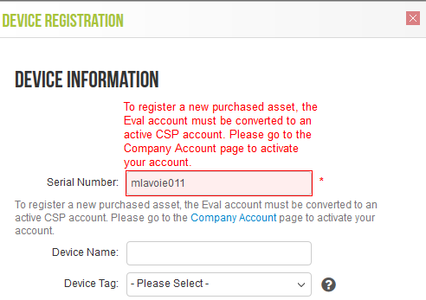
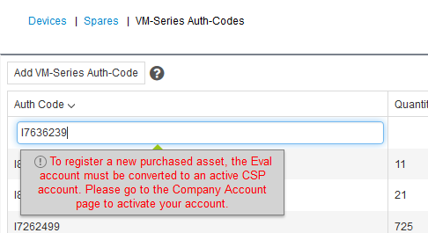

Company Account
For Eval accounts, the company account page will show a label “Eval” to indicate the account is an eval account. Next to the label will be a small form for activating your account (converting to a paid customer account).
There will be a textbox labelled “Serial Number or Auth Code” and a button labelled “Activate this Account”. Additionally there will be a note stating “To convert an eval account to an active account, please enter a purchased serial number or auth code.”.
After clicking “Activate this Account” we will validate the device code. We will start by checking the support account it is tied to in our SAP Sales Order History table. If the associated account is already active (has super users or assets) then we’ll show the associated company name and ask for confirmation before proceeding: “The account associated with this device code is already active in an account named COMPANY NAME. If that is correct you may register to that account. If the account name is inaccurate, please cancel and contact Customer Support”.
If they click to proceed we’ll add the user to the account with the default role, notify the super users and display this message: “An active account has already been created using this code. You have been added the active account and can now change to that account.”.
If the associated account was never activated, then we’ll show the associated company name and ask for confirmation before proceeding: “By proceeding you will activate this account. Our records indicate the device code you provided was sold to COMPANY NAME. If this is correct please complete the activation. If the account name is inaccurate, please cancel and contact Customer Support”. If they click proceed we’ll convert the eval account to a paid, customer account and delete the inactivated duplicate account.
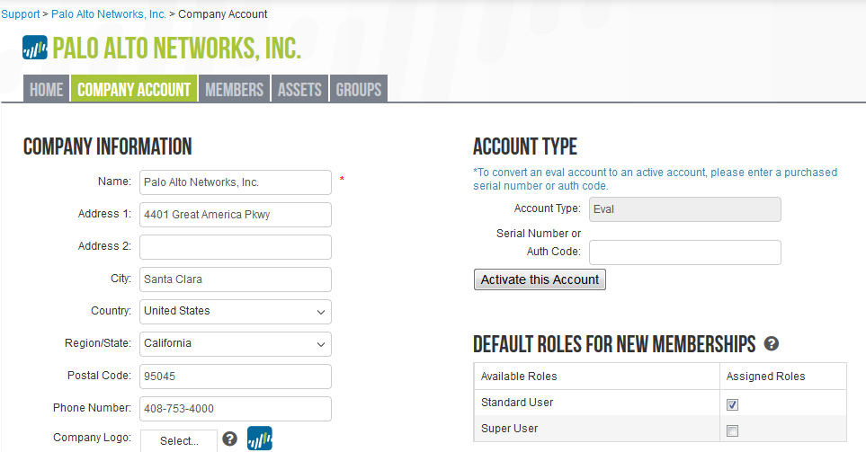
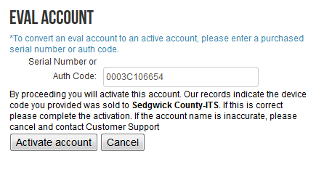

Salesforce VM Eval Request Services
Two web services will be added to the CSP to support VM Eval requests which come almost exclusively from salesforce. The salesforce team has agreed to call our web services when a VM Eval is requested and when a VM Eval order is updated with more devices – but this piece has been delayed until after our project. In the meantime we will be responsible for reading from cs.device.CustomerServiceNotes where they start with EVAL-%. We will then call the service, ourselves, simulating what the Salesforce team will do when their code is complete. This will need to be a scheduled console app that runs regularly (every 5 minutes) to make sure we quickly create these new support accounts.
Our service will receive these requests and create a support account if necessary. It will additionally log the vm device information to support self-service registration.

Eval Account Conversion Flowchart
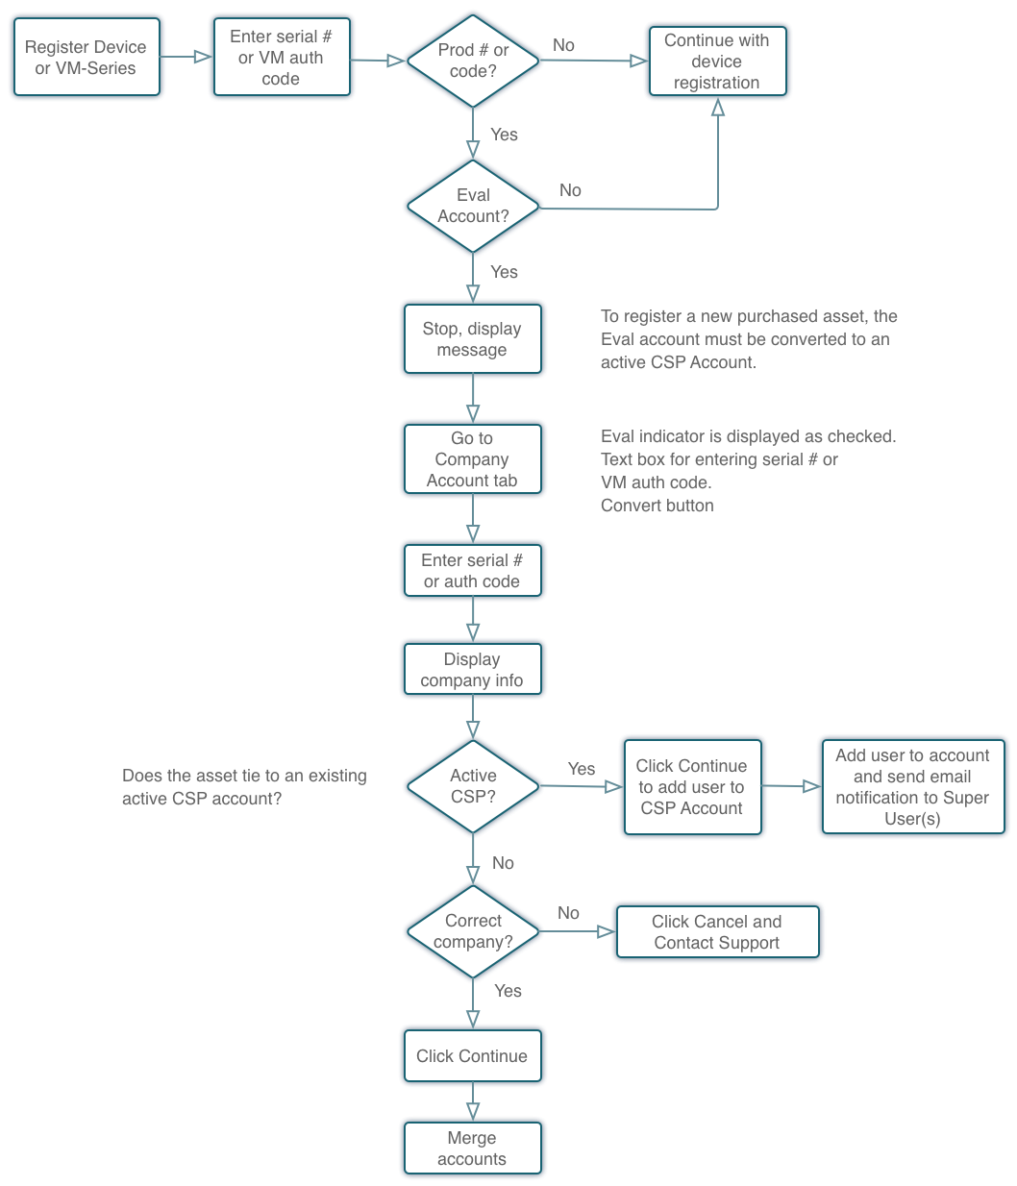

Eval Tracker

Transfer to Customer Site
In Eval Tracker, if the SE chooses to transfer a device to a Customer Site (after whacking the device) we’ll update the logic supporting Eval ID. After entering the Eval ID we validate it against salesforce and auto-fill the rest of their support account information for them based on the salesforce request. They can then confirm they entered the correct eval id and if so submit the request. After submitting we’ll create a support account if no exists already.

Admin Site

SE Device Creation
The SE Device creation page is sometimes used by SE’s to improperly create VM evals for customers. We will add a check box to the page titled “For Customer Evaluation”. If checked, the SE will be able to enter an Eval ID (required).
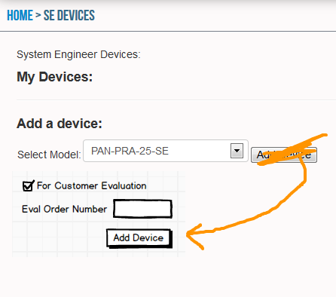
When an Eval ID is provided, we’ll validate it against Salesforce and retrieve the support account information. If the eval id is invalid, we will prevent account creation. We’ll then create a new eval support account if no matching support account already exists and log the eval request.

Entitlement Search
The entitlement search will be enhanced to display the account type of the customer: PAN, Cust, ASC or Eval.
This has been completed

Salesforce

VM Eval Requests
Salesforce handles most VM Eval requests currently and connects directly to the licensing server to create the auth codes. The Salesforce team has agreed to update their process to call our new VM Eval Request web services to alert us of any VM eval requests or additions to requests.
Their timeline is still being developed.
In the meantime, we will be responsible for reading from cs.device.CustomerServiceNotes where they start with EVAL-%. We will then call the service, ourselves, simulating what the Salesforce team will do when their code is complete. This will need to be a scheduled console app that runs regularly (every 5 minutes) to make sure we quickly create these new support accounts.

